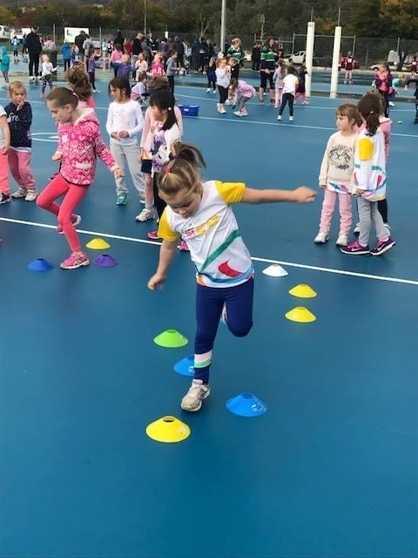

Netball ACT
Return to Play in a COVID-Safe Environment Plan

Netball ACT pays respect to the traditional custodians of our ancient continent, Aboriginal and Torres
Strait Islander peoples, we honour their continuing connection to country and their custodianship of

the world’s oldest living culture.

PURPOSE
Netball ACT has drafted this document in line with the ACT Governments framework for community sport in the ACT, to assist District Associations and clubs in the development of their Return to Play in a COVID-Safe Environment Plans, as required within that framework.

SCOPE
It is a requirement of the ACT Government that a “Return to Play in a COVID – Safe Environment Plan” be prepared by each individual sporting organisation including peak bodies, associations and individual clubs. Netball ACT has developed this plan to be utilised by the ACT Netball community to ensure compliance across our sport with government requirements. Associations are to submit their completed Return to Play in a COVID – Safe Environment Plans directly to Netball ACT and Clubs, directly to their District Association for acceptance and sign off, prior to re-commencement of netball activities within the ACT Government guidelines.

To assist in the preparation of individual plans, we strongly recommend reference to the ACT Governments “Framework for community sport in the ACT” document: https://www.sport.act.gov.au/__data/assets/pdf_file/0009/1662966/PICC0149-Return-To-Sport-Framework.pdf

Further information can also be found on the “Return to Netball” page on the Netball ACT website at: https://act.netball.com.au/return-netball

ORGANISATIONAL DETAILS
Name of affiliated District Association:

Name of affiliated Club:

Venue(s) to which this plan relates:

Date completed:

Return to Play Framework | Return to Play Considerations | Association / Club Actions
Hygiene | Pre & post activity
 | Provision of Hand sanitiser
 | No sharing of personal equipment
 | Spitting & nasal secretions
 | Limited sharing of equipment
 | Use of communal facilities
 | Unwell participants
Physical Distancing | "Get in, train, get out"
 | Separated small groups of 10
 | Physical contact between participants
 | Adequate spacing (1 person x 4 square metres)
 | Spectators / parents / carers
 | Venue entry / exit procedures
Activity / Sport Specific | Training formats (i.e. - small groups)
 | Protocols - capture & recording of participant details including use of Australian Government COVIDSAFE app
 | Defined training spaces ensuring adherence to hygiene and physical distancing principles
 | Instructions to participants on training practices
 | Equipment cleaning protocols
 | Avoid physical contact (Training / Social)
 | Any other venue specific protocols
Communication | Communication to participants around training formats & expectations
 | Communication to participants around the need for Contact Tracing register
 | Clear guidance for staff, coaches & volunteers on activity requirements
 | Venue signage
 | Inform parents and spectators on their responsibilities
 | Making Return to Sport in COVID-safe Environment Plan accessible
Incident Management | Protocols for quarantine /self-isolation in the event of a positive result within your organisation
Review and Monitor | Process for review and monitoring

DECLARATION
This plan has been reviewed and endorsed by:

Name:

Association / Club Position held:

Signature:

Date:

- SIGN OFF
This plan has been reviewed by Netball Association and approved by:

Name:

Netball ACT / District Association Position held:

Signature:

Date:

